**Assingment - 2**

* **Add a 10GB disk to the CentOS.**

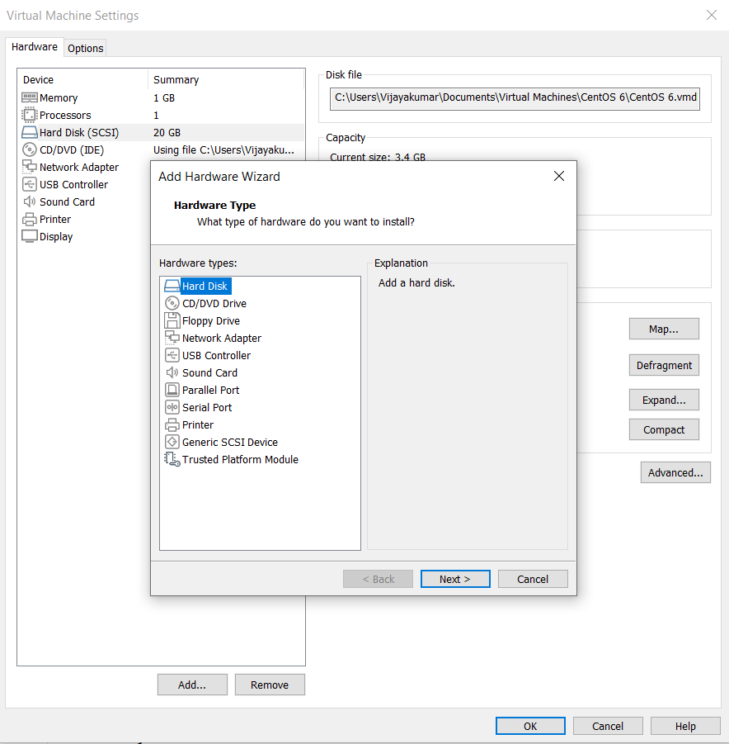

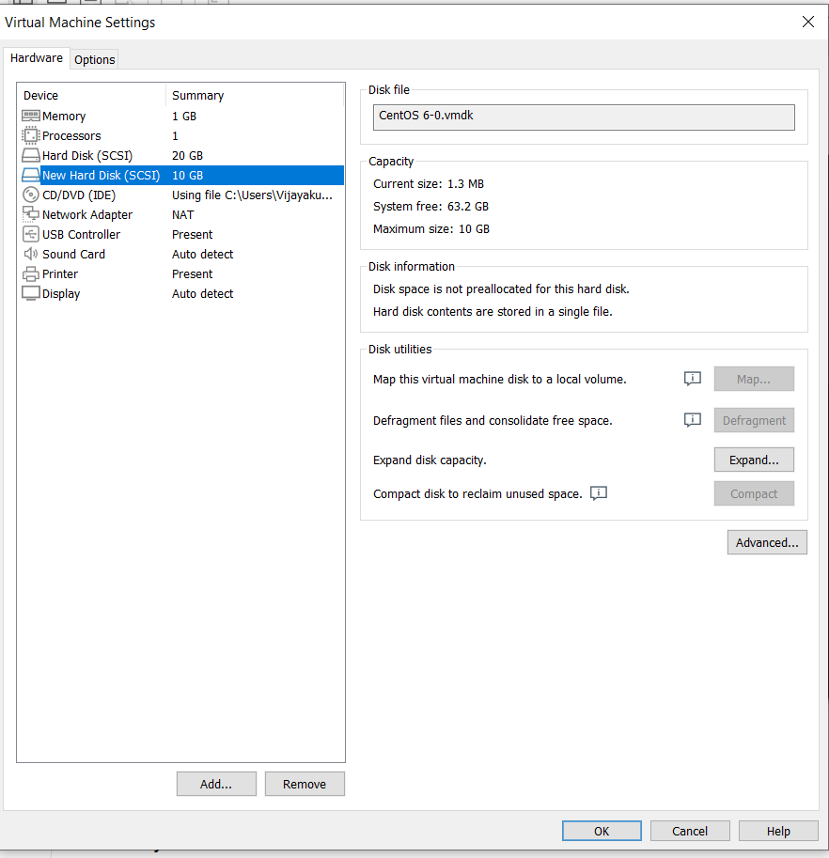

* **Create 2 Partitions 4GB and 6GB of Space respectively.**

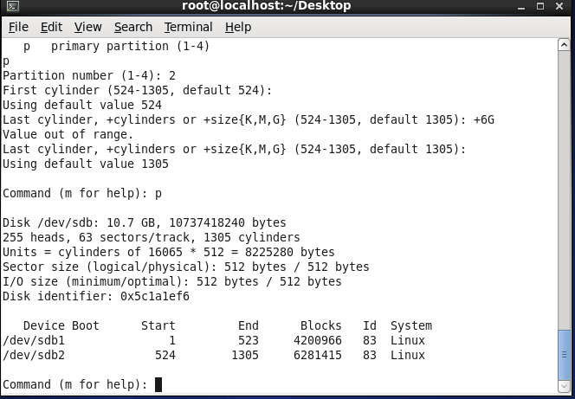

* **Format 4GB with xfs and 6GB with ext4 file system.**

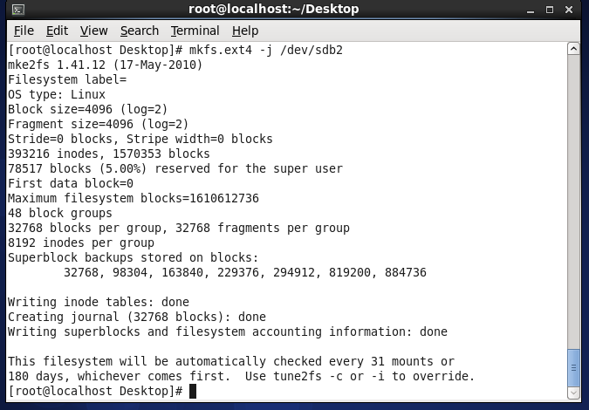

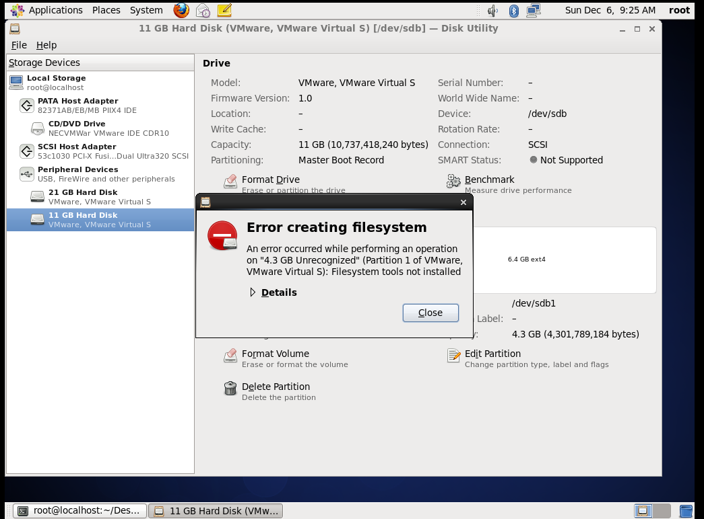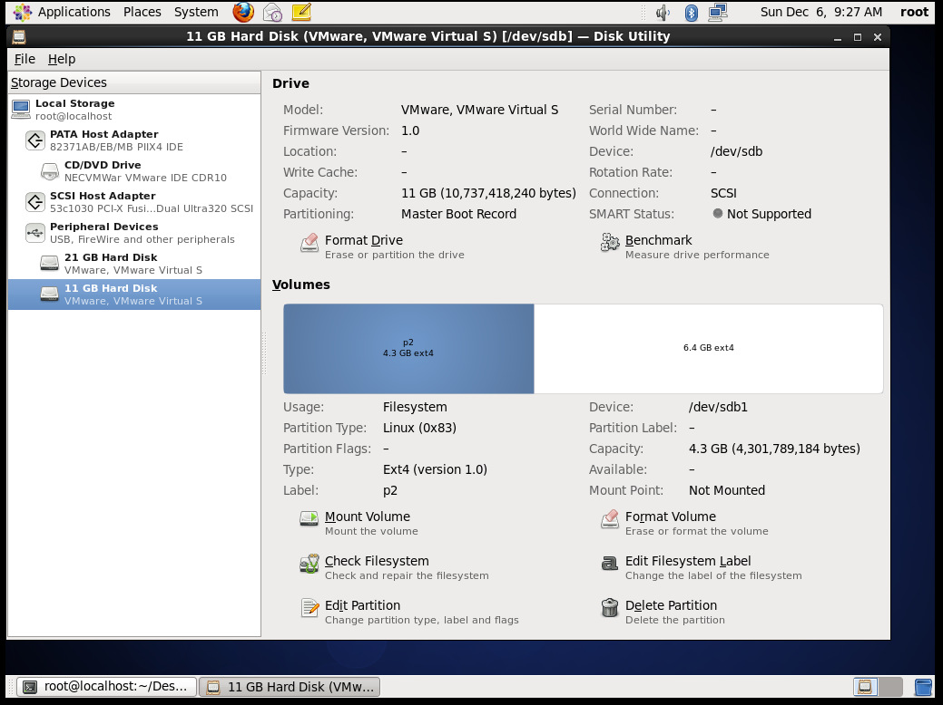

* **Mount 4GB and 6GB in /data and /music directory respectively.**

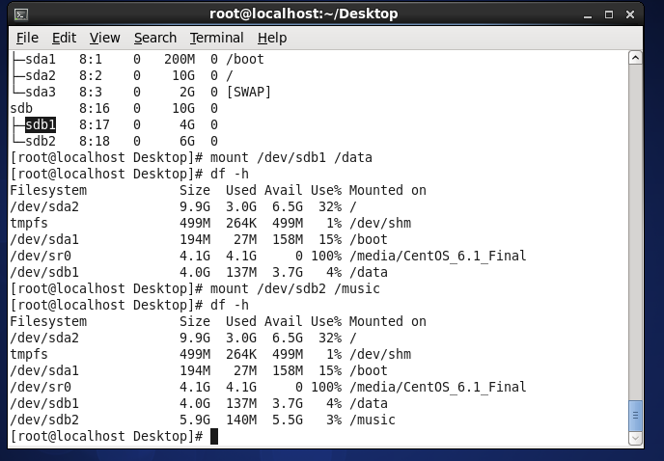

* **Create one file of 1GB in each of the mount point created above.**

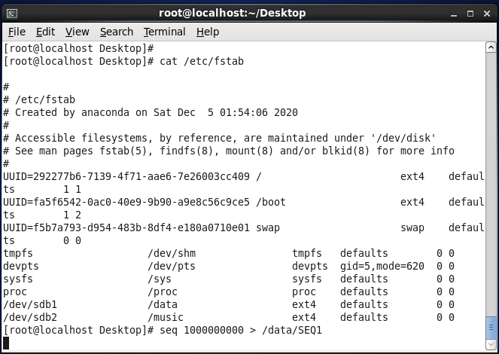

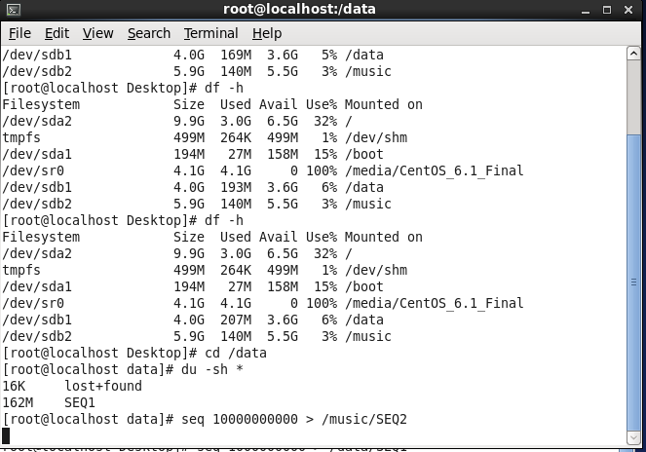

* **Verify the disk Consumption and disk space free in the mounted partitions.**

